Dr. Juri Karjagin
President
Estonian Society of Anesthesiologists (ESA)

Subject: 2022 WINFOCUS WORLD CONGRESS (WF WC 2022) – “Waves empowering healthcare” (Dec 1- 4. 2022)

Dear Dr. Karjagin,

The World Interactive Network Focused on Critical Ultrasound (WINFOCUS, http://www.winfocus.org), a global leader in Point-of-Care Ultrasound (PoCUS) will hold its annual World Congress in the first week of December (Dec 1st - 4th). It will have the unique format of a hybrid, multi-venue, multi-lingual event, consisting of 4 distinct components (see attached congress flyer, and additional infos at www.winfocusworldcongress.com).

There will be an on-ground component to be held in Antalya, Turkey. This will consist of Pre-Congress courses and workshops (PCCs) on December 1st and 2nd, and a stripped-down in-person Congress (IPC) on the 3rd and 4th of December, run jointly with the 18TH TURKISH CONGRESS ON EMERGENCY MEDICINE (EACEM 2022) and the 8TH EURASIAN CONGRESS ON EMERGENCY MEDICINE.

Second, there will be a Virtual Congress (VC) similar to 2021, which will run concurrently with the on-ground Congress on Saturday and Sunday the 3rd and 4th of December. Like last year, the Virtual Congress will be made up of approximately 20-minute pre-recorded talks, grouped by theme into sessions of about two hours, the last 20 minutes of which will be represented by a live panel discussion. Thanks in large part to quality of the presentations, the stature and amazing efforts of speakers, moderators, and session co-chairs, and the endorsement of several organizations, over 18,800 people from 65+ countries registered at last year’s edition of WF WC, and many sessions were attended by well over 1500 people (scientific program and list of endorsements to WF WC 2021 available at: http://www.winfocusworldcongress.com/beta).

On December 3, there will be a fourth major component of the 2022 World Congress consisting of continuously running in-person ultrasound courses (Basic, Cardiac, Lung, etc) in about 80 locations from Australasia in the east across the globe to the countries of the western hemisphere. We have given these workshops the acronym POW! – “Point-Of-care One-world Workshops” – in the hope of invoking the spirit of a Marvel comic superhero who deals with enemies of truth and progress with a well-placed POW! The workshops will link to the Antalya Congress. We are organizing them with the goal of promoting global awareness of PoCUS and ultrasound teaching as a continual force for the good. December the 3rd will be in fact celebrated as “PoCUS Awareness Day” worldwide and as such promoted by means of a media and social media campaign.

WINFOCUS strongly believes that PoCUS adds critical value to patients’ management and outcomes. In order to ensure the widest possible access for the global medical community, WINFOCUS has decided to offer the event for free to all members of medical societies and academic institutions that use PoCUS in their clinical practice or are engaged in its teaching and promulgation.

In this regard and as part of our campaign, we are seeking the availability of your prestigious organization, to offer the registration to the virtual component of 2022 WINFOCUS World Congress – “Waves empowering Healthcare” free of charge to its members.

Therefore we would request your organization’s endorsement of this event. No financial obligations are by this mean requested. We would be greatly honored by your participation, which would allow you both to contribute to the success of this scientific endeavor and to share in the credit for making it happen.

We look forward to hearing from you at your earliest convenience. We will be glad to answer any questions or concerns you might have.

Thanking you in advance for considering this request.

Sincerely,

Anthony J. Dean,
WINFOCUS Secretary
Chair, Scientific Committee, 2022 WINFOCUS World Congress
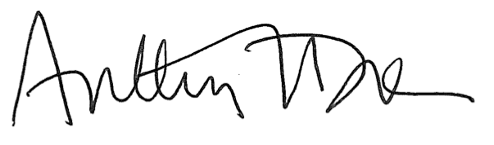

Gabriele Via, M.D., EDIC
WINFOCUS President
Chair, Organizing Committee, 2022 WINFOCUS World Congress
Co-Chair, Scientific Committee, 2022 WINFOCUS World Congress
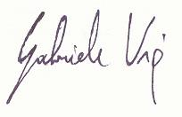
Arif Hussain, MD, FRCA, FCCP
WINFOCUS Past President
Co-Chair, Organizing Committee, 2022 WINFOCUS World e-Congress

